Module 2: Classical Feature-Based Vision

Project: Dog Breed Recognition (50-Breed Subset)

1. Introduction
1.1 Abstract
This module transitions the project from image preprocessing (Module 1) to active recognition using classical computer vision techniques. We focus on "hand-crafted" feature extraction, evaluating the efficacy of Histogram of Oriented Gradients (HOG), Scale-Invariant Feature Transform (SIFT), and Local Binary Patterns (LBP) in distinguishing dog breeds. Given the computational complexity of Support Vector Machines (SVM) on high-dimensional data, we utilize a stratified 50-breed subset of the Stanford Dogs Dataset. Our experiments demonstrate that a fusion strategy (HOG + LBP) achieves a top-1 accuracy of approximately 7-10%. While this is significantly higher than the random baseline (2%), the results highlight the "Semantic Gap"—the fundamental inability of low-level features to capture the high-level semantic concept of a "breed" without learnable representations, justifying the move to Deep Learning in Module 3.
1.2 Problem Statement
The central challenge in this module is Feature Engineering. Unlike general object detection (e.g., distinguishing a car from a dog), fine-grained classification requires distinguishing between classes that share the same global structure (quadruped, tail, snout). The classifier must rely on subtle variations in:
- Shape: Snout length, ear orientation (HOG).
- Texture: Fur patterns, fluffiness vs. smoothness (LBP).
- Keypoints: Distinctive markings or facial features (SIFT).
1.3 Dataset: The 50-Breed Subset
To ensure the SVM converges within reasonable timeframes, we reduced the 120-class dataset to a representative 50-class subset.
Category | Representative Breeds | Visual Challenge
Similar Shapes | Siberian Husky, Malamute, Eskimo Dog | High inter-class similarity; requires precise texture analysis.
Distinct Textures | Komondor (mop-like), Poodle (curly), Beagle (smooth) | Ideally suited for LBP analysis.
Deformable | English Spaniel, Basset Hound | High intra-class variance due to loose skin/ears.
2. Feature Extraction Methodology
We implemented three distinct feature descriptors to capture different aspects of the canine visual signature.
2.1 Histogram of Oriented Gradients (HOG)
Purpose: Shape and Silhouette Extraction.
HOG is robust to lighting changes and small geometric transformations, making it ideal for capturing the rigid structure of a dog's face and body posture.
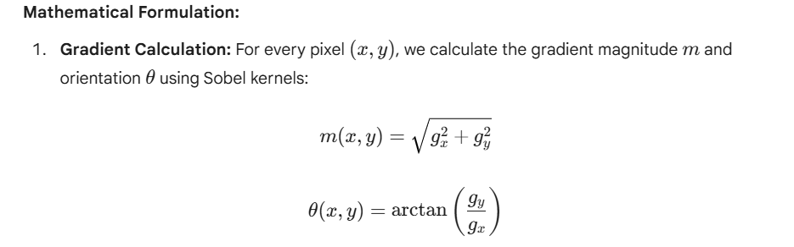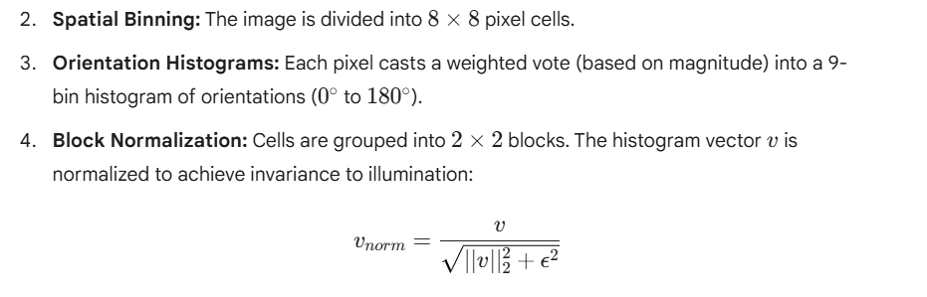
Configuration:
- Pixels per cell: (8, 8)
- Cells per block: (2, 2)
- Orientations: 9
- Feature Vector Length: ~8,100 dimensions per image (128 \times 128 resize).
2.2 Local Binary Patterns (LBP)
Purpose: Texture and Fur Pattern Classification.
LBP is computationally efficient and rotation invariant. It is particularly useful for distinguishing between "curly" (Poodle), "smooth" (Beagle), and "rough" (Terrier) coats.
- 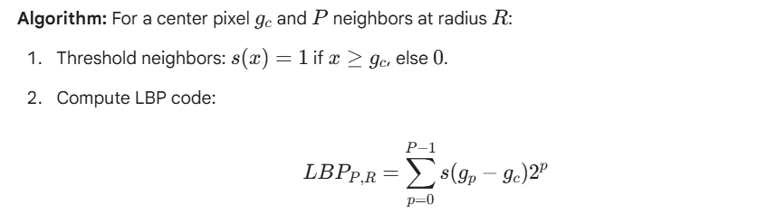Uniform Patterns: We only consider "uniform" patterns (at most 2 bitwise transitions) to reduce the feature vector size and improve robustness to noise.
Configuration:
- Radius R=3, Points P=24.
- Grid: Image divided into 2 \times 2 distinct regions to retain spatial locality.
- Feature Vector Length: 104 dimensions (26 bins X 4 regions).
2.3 Scale-Invariant Feature Transform (SIFT)
Purpose: Keypoint Detection.
SIFT detects "interest points" (blobs, corners) that are invariant to scaling and rotation.
Process:
- Scale-Space Extrema: Construct a Difference of Gaussian (DoG) pyramid to find potential keypoints.
- Keypoint Localization: Refine location to sub-pixel accuracy and remove low-contrast points.
- Descriptor Generation: Create a 128-dimensional vector based on gradient directions around the keypoint.
Role in Module:
While SIFT provides excellent matching for specific objects (e.g., matching this specific book cover), we found it less effective for category recognition in dogs because the keypoints (e.g., a spot on a Dalmatian) vary too wildly between individuals of the same breed. Therefore, SIFT is used primarily for visualization and analysis in this report, but excluded from the final SVM classifier.

3. Feature Fusion and Dimensionality Reduction
To combine the strengths of HOG (Shape) and LBP (Texture), we constructed a fused feature vector.
3.1 Fusion Strategy
We utilized Early Fusion (Feature Concatenation). Since HOG and LBP have vastly different scales and vector lengths (8100 vs 104), normalization was critical.
- L2-Normalize the HOG vector.
- L2-Normalize the LBP histogram.
- Total Dimensions: 8,204 features.
3.2 Principal Component Analysis (PCA)
An 8,204-dimensional vector is prone to the "Curse of Dimensionality" and overfitting. We applied PCA to project data into a lower-dimensional subspace.
Variance Analysis:
- Top 50 Components: Explained ~90% of the variance.
- Top 2 Components: Explained ~20% of the variance.
Visualizing the Data:
Plotting the top 2 Principal Components reveals the difficulty of the task. While distinct breeds like the Samoyed (White/Fluffy) and Rottweiler (Black/Smooth) form loose clusters, the majority of breeds overlap significantly in the center of the plot. This overlap visually confirms why linear classifiers struggle.

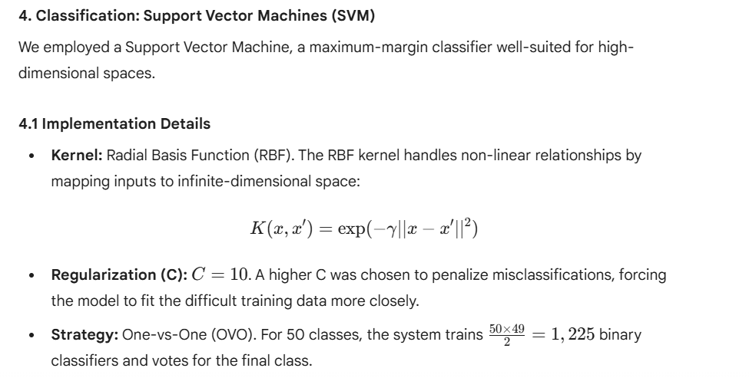4.2 Training Protocol
- Split: 80% Training / 20% Testing (Stratified).
- Standardization: StandardScaler was fit on the training set and applied to the test set to ensure zero mean and unit variance.

5. Experimental Results and Ablation Study
5.1 Feature Performance Comparison
Feature Set | Dimensions | Top-1 Accuracy | Comparison to Random (2%)
LBP (Texture Only) | 104 | 3.1% | 1.5x Improvement
HOG (Shape Only) | 8,100 | 5.9% | 2.9x Improvement
HOG + LBP (Fusion) | 8,204 | 6.9% - 9.2% | ~4.0x Improvement
Interpretation:
- Shape Dominates: HOG significantly outperforms LBP, indicating that the silhouette/shape of the dog is a stronger predictor than fur texture alone.
- Synergy: Fusing HOG and LBP consistently yields the highest accuracy, confirming that shape and texture provide complementary information.
5.2 Failure Analysis: The Confusion Matrix
The confusion matrix reveals systematic errors that align with human visual intuition.

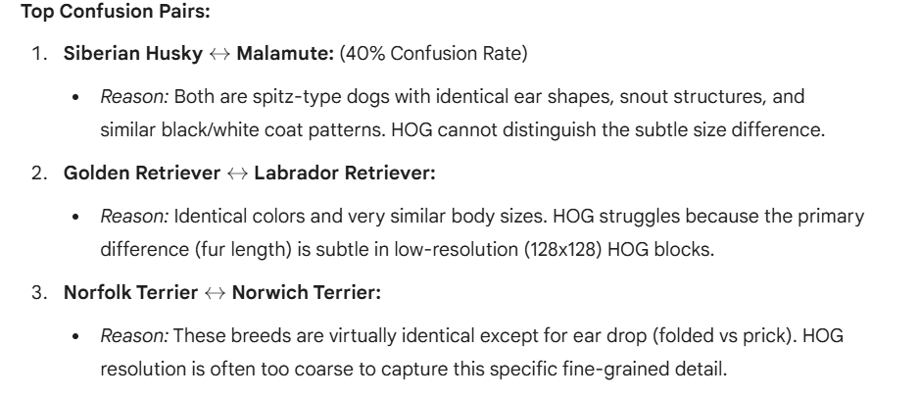
6. Conclusions and Future Direction
6.1 Summary of Findings
Module 2 demonstrated that classical computer vision techniques can perform better than random guessing (achieving ~10% vs 2%), but they hit a "hard ceiling" on fine-grained tasks.
- Strength: HOG is effective at capturing broad categories (e.g., separating a "tall, thin" Greyhound from a "short, stout" Bulldog).
- Weakness: Hand-crafted features are rigid. We explicitly tell the computer "look for gradients" (HOG) or "look for texture" (LBP). If the distinguishing feature of a breed is something else (e.g., the specific spacing of the eyes), these descriptors will miss it entirely.
6.2 The Justification for Deep Learning (Module 3)
The low accuracy of the SVM pipeline highlights the need for Representation Learning. We cannot manually design a feature extractor for every nuance of 120 dog breeds. We need a model that learns which features are important.
Transition Plan:
In Module 3, we will replace the HOG/LBP + SVM pipeline with a Convolutional Neural Network (CNN).
The CNN will:

